Pac Fung - 888183, 888527

Dunsky – 892465

go to pac fung (22978/34681)

go to 881499/50 old MC

edit => see err message

Cancel

go to 888183 old MC

create 888183/50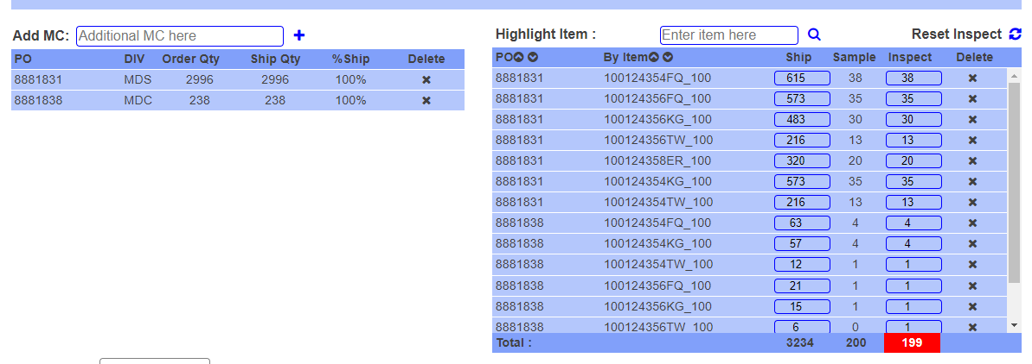

delete 8881831 till the last one

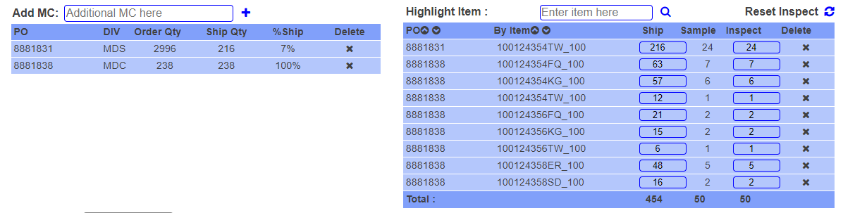

delete 8881838 till the last one

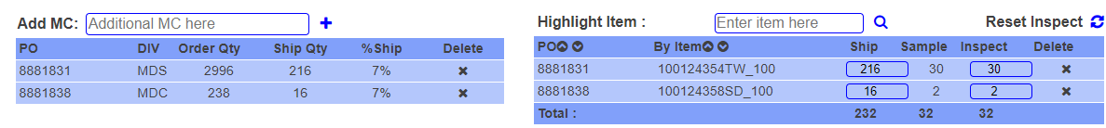

Edit 8881831 to only inspect 28

Edit 8881838 to only ship 15

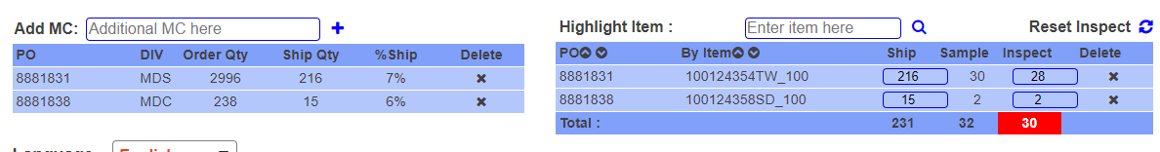

Save and return – check if they retain

Remove 8881838 on the right, don’t save



Cancel remove



Remove 8881831 on the left, save 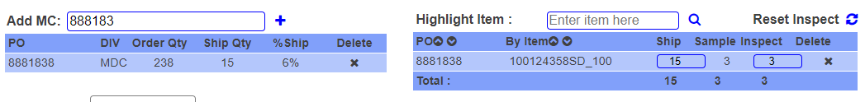

Search 888183 and see if saved properly.

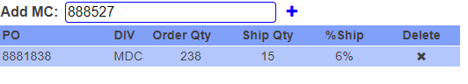

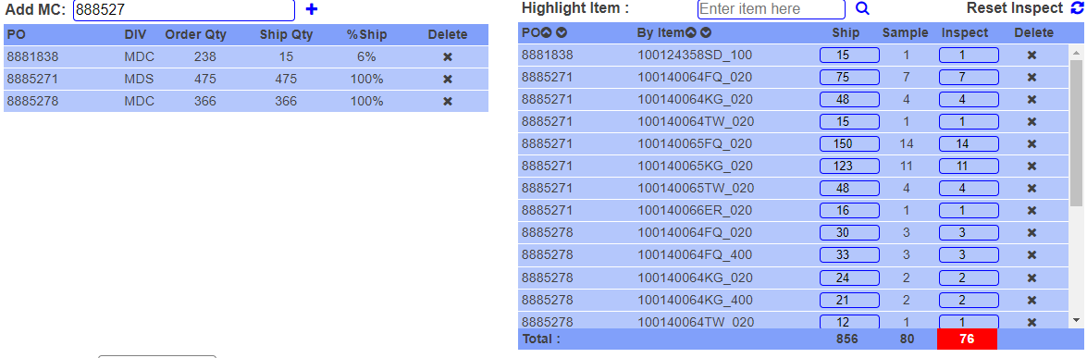

Delete 8885271 on the left

Change ship qty from 16 to 15 on the left

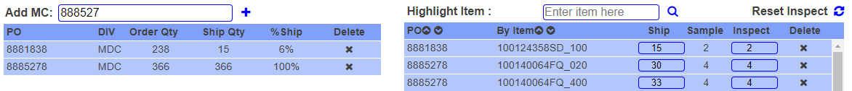

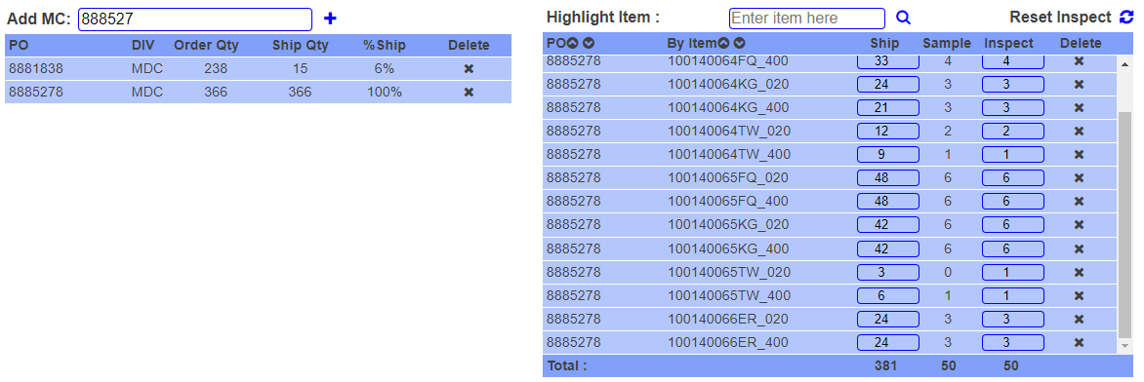

Delete 8885278 on the right, from the top till last one

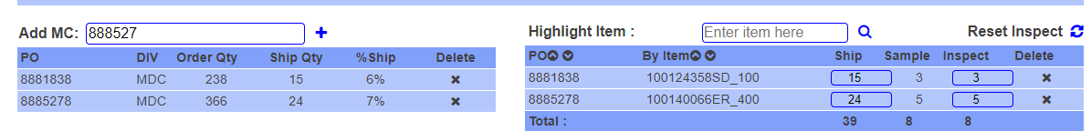

Save and verify same

Delete 8881838 on the right

Change inspect 6

Save and verify same

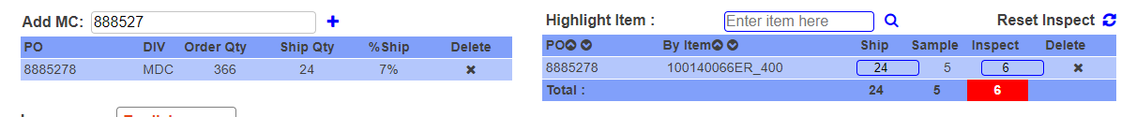

Delete 8885278 on the left



Save and verify same

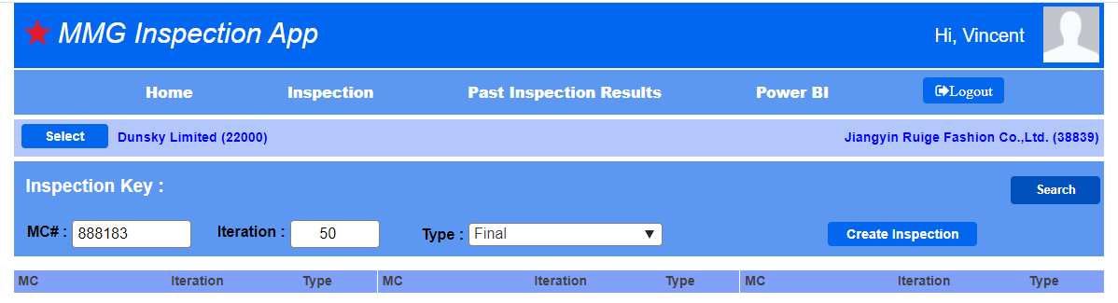

Should see below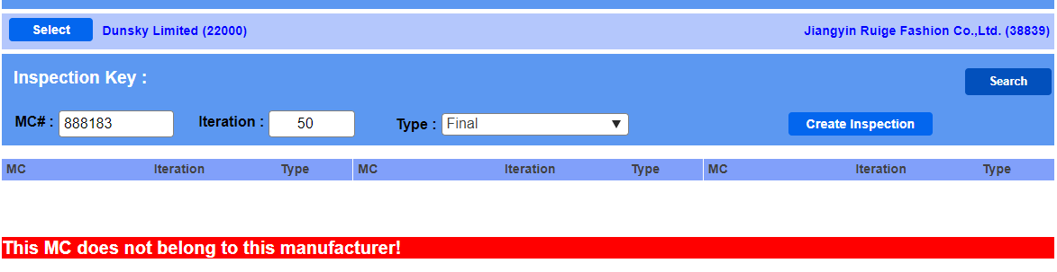

Go to empty 888183 /50 and reduced to below, change ship last qty from 24 to 23

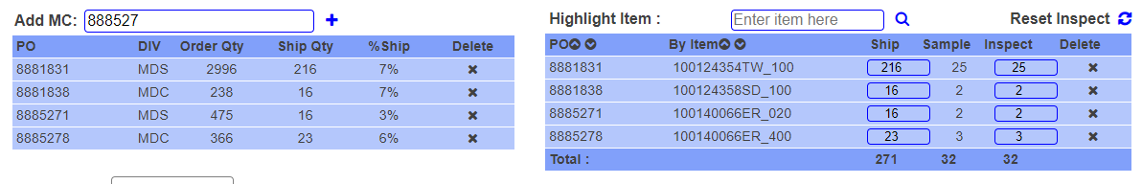

Change 1st row inspect qty from 25 to 24

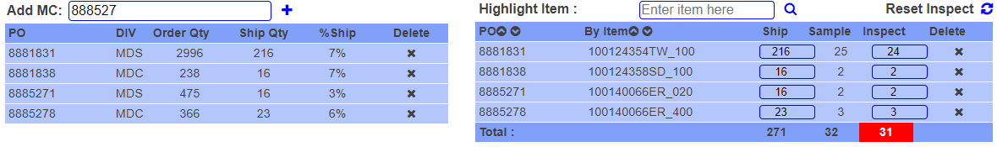

\*\*End\*\*